**Microsoft Azure Storage Explorer Documentation**

**Goal**

The goal of this setup is to install Microsoft Azure Storage Explorer, sign in, and access stored files from Azure Storage accounts.

**Steps to Use Azure Storage Explorer**

**Step 1: Download and Install Storage Explorer**

1. Go to the official Microsoft website: https://azure.microsoft.com/en-us/features/storage-explorer/
2. Download the version suitable for your operating system.
3. Install the application on your computer.

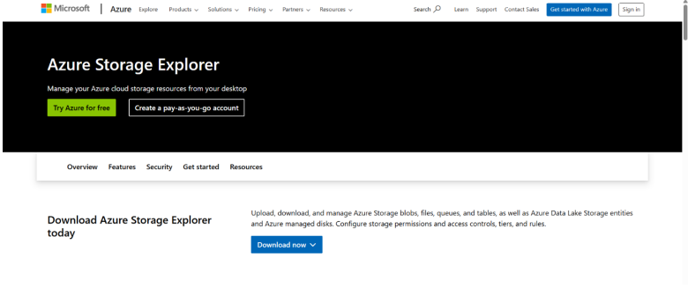

**Step 2: Open Storage Explorer**

1. Launch **Microsoft Azure Storage Explorer** after installation.
2. The home page will be displayed.

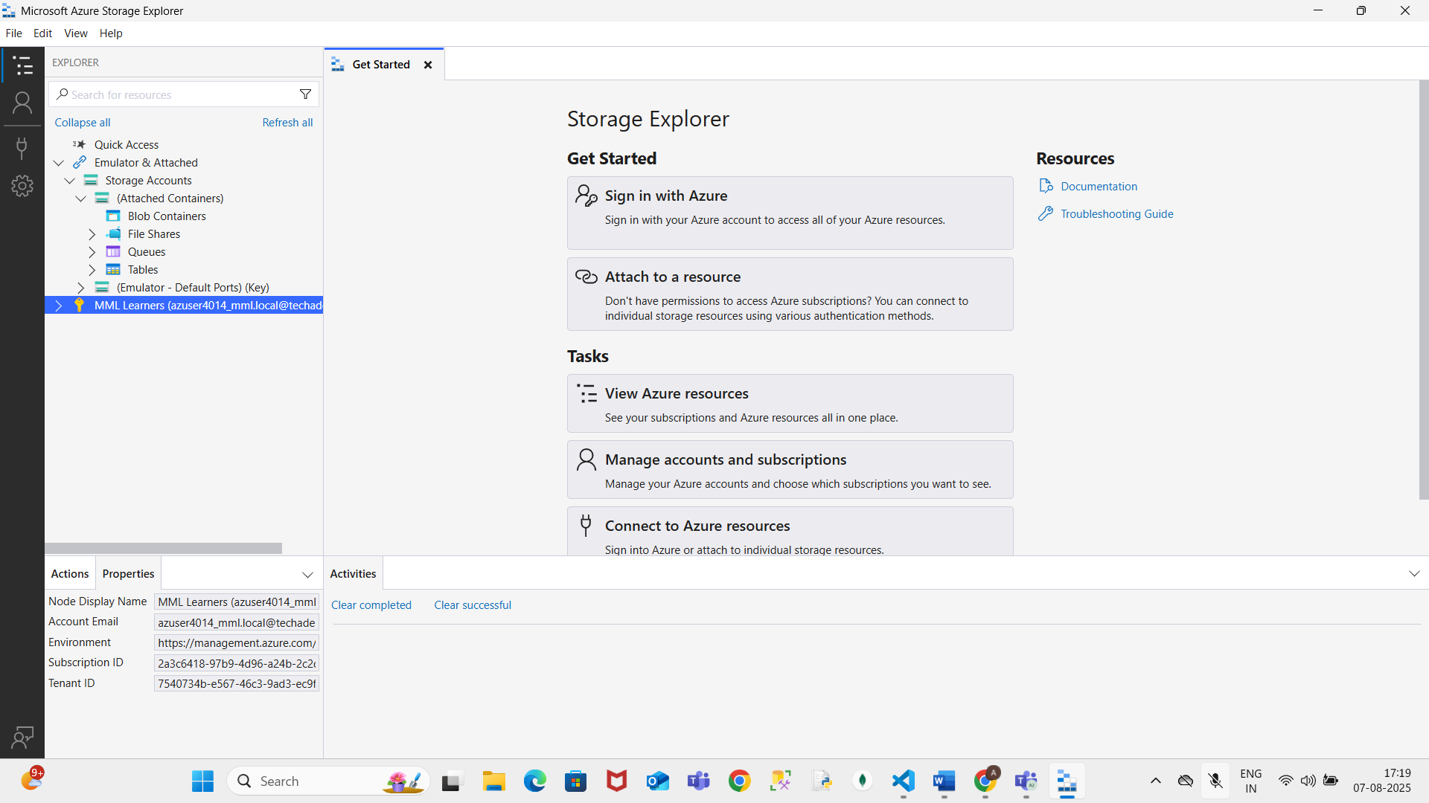

**Step 3: Sign In to Azure Account**

1. Click **Sign in** at the top left.
2. Use your Azure account credentials to sign in.

**Step 4: Access Storage Account**

1. In the left panel, expand **Storage Accounts**.
2. Select the storage account you want to view.

**Step 5: Navigate to Blob Container**

1. Under the selected storage account, expand **Blob Containers**.
2. Click on the desired blob container.
3. You will see the list of files stored in that container.

**Step 6: View Stored File**

1. Click the file name to open and view it.
2. The file content will be displayed in Storage Explorer.

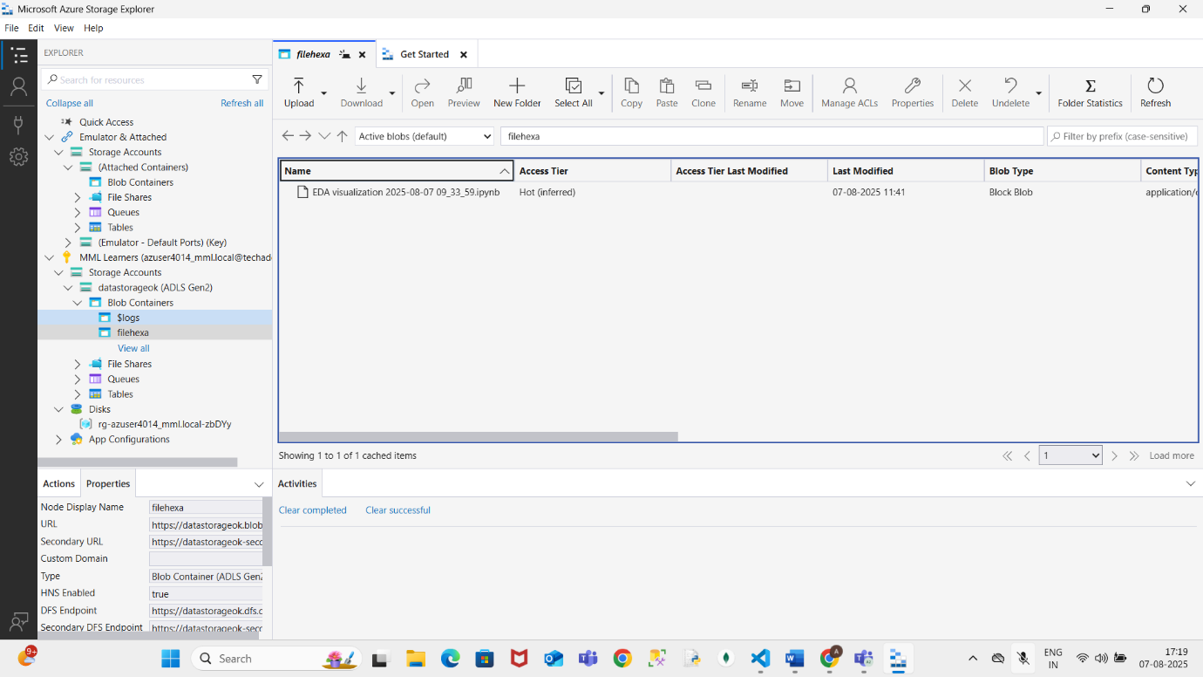

**Conclusion**

You have successfully installed Microsoft Azure Storage Explorer, signed in to your Azure account, and accessed files stored in a blob container.